Ghost runner

Summary:

Ghost Runner is a fast-paced endless runner game set in a dynamic world that blends ancient castles and modern cities. Players navigate through challenging obstacles while collecting coins, avoiding traps, and outrunning a mysterious ghost. With vibrant visuals, diverse characters, and thrilling gameplay, Ghost Runner offers an immersive and adrenaline-filled experience

Art style:

The game's dynamic and stylized visual style has the goal of appealing to a wide range of players, from adults to teenagers. Aiming for a mix between entertaining and immersive, the graphics combine realistic aspects with exaggerated, cartoonish elements. The graphics, which are influenced by games like Temple Run and Subway Surfers, have bright colors, sharp textures, and smooth character motions that add to the game's lively and fun atmosphere.

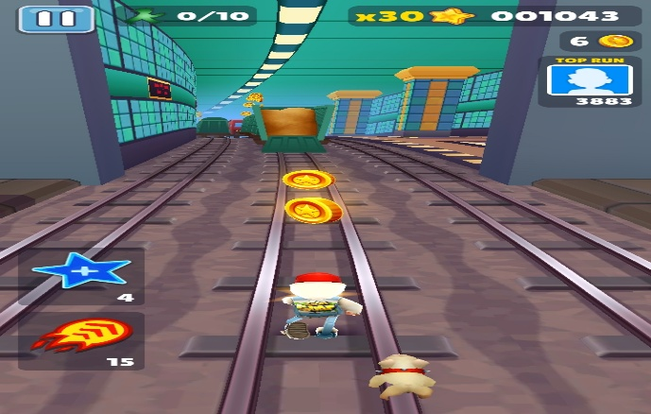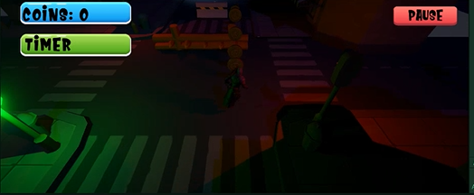

Environment:

To create a mix of ancient and urban design, the game is set in a dynamic combination of castle and city settings. Stone-paved streets, castle walls, towers, curves, and urban features including stores, obstacles, lamps, stairs, and neon-lit signs are examples of environmental assets. A rich, immersive universe with both historical and modern elements is produced by combining these resources.

While the city parts include painted lane markers for easy navigation, darker streets, and glowing obstacles, the castle areas have textured stone surfaces, tight routes, and towering features. With a blend of dark and brightly light parts, the setting aims to be visually attractive, directing the player's attention while preserving a pleasing and well-balanced style.

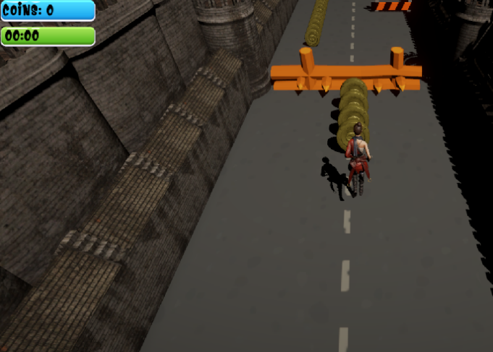This blend of urban and historical environments produces a unique and seamless experience that improves the game's overall mood and playability.

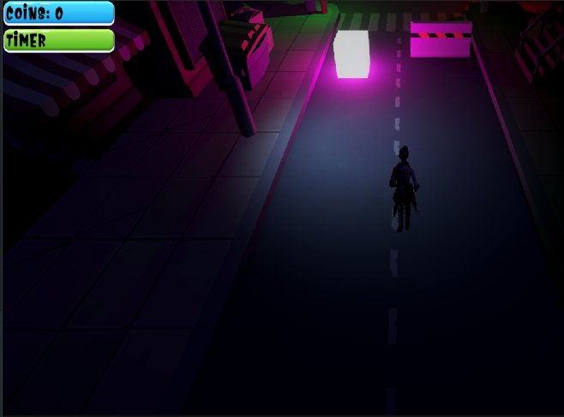

Characters:

A wide range of characters with different designs and styles are included in the game to improve the player's experience and engage with it. The characters fit the castle and city settings by mixing elements of historical, modern, and adventurous styles.

**Fayrouz**: A skilled warrior with a stylish, quick appearance, dressed in a red and black even. She is the perfect character for fast-paced gaming because of her design, which places an emphasis on speed and skill.

Rawan: Rawan's dark, leather-based clothing gives a strong and strategic presence. Her tough appearance reflects her capacity to navigate through difficult situations while remaining alert and focused.

Salma: Salma's stylish, modern white bodysuit and trendy look make her stand out. Her design, which represents reliability, technology, and creativity, gives the game a science-fiction touch.

Marwan: Marwan is a strong, armored figure with a more historical-inspired style that includes battle-worn detailing and elaborate plating. His powerful presence conveys strength and perseverance, making him ideal for overcoming difficult challenges.

Omar: Omar has a powerful and strong appearance owing to his design, that includes aspects of military clothing and historical metal. His clothes, which include layered details and a helmet, convey strength and control.

Each character is carefully crafted to bring variety and personality to the game, ensuring players have a range of styles to enjoy while navigating through the dynamic castle and city environments.

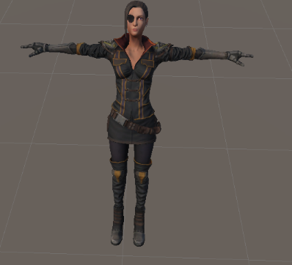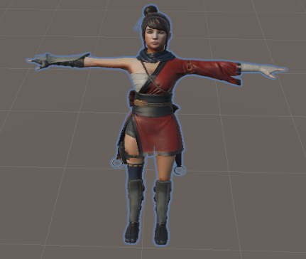

Salma

Rawan

Fayrouz

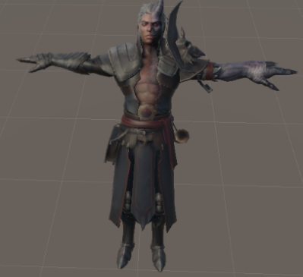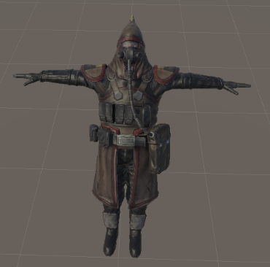

Marwan

Omar

Ghost Chase:

The ghost is a key element in the game, constantly pursuing the player character. creating an additional layer of tension and urgency. As the character runs through the city or castle, the ghost chases them, forcing the player to navigate obstacles while being pursued. The ghost adds an exciting dynamic to gameplay, making the environment feel more dangerous and challenging.

Obstacles:

The game features a variety of obstacles that add challenge and excitement to the gameplay. Two types of **barriers** serve as primary obstacles, blocking the player's path and requiring quick reflexes to either jump over or maneuver around them. These barriers are designed to test the player's agility and decision-making, especially in tight situations. The **Train obstacle** introduces an element of unpredictability, as a train forces players to carefully time their movements to avoid collisions. Spike obstacles, which have sharp, retractable spikes and demand accurate jumps to avoid being grabbed, add a high-stakes element. Together, these obstacles keep the gameplay dynamic and engaging, ensuring players are constantly on their toes.

Spike

Barrier 1

Barrier 2

Train

Main Menu:

The **main menu** features a simple **city background** with a **Start button** and the game name. The scene includes basic buildings, streetlights, and a clear sky, giving a clean and straightforward urban feel to the menu.

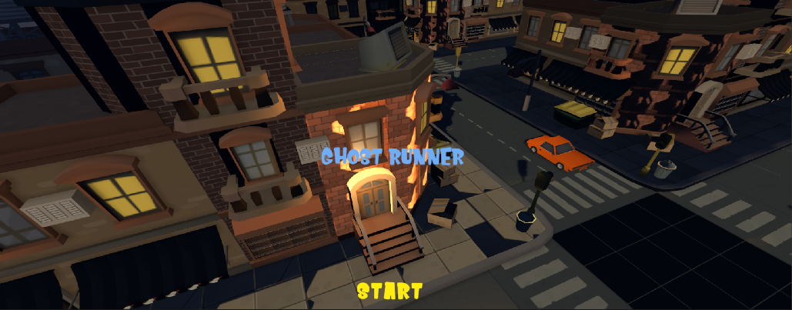

Submenu:

The **sub-menu** includes a description of the game in a scrollable view, allowing players to read about the gameplay and features. Below the description, a **Play button** is displayed, giving players the option to start the game after they've explored the details.

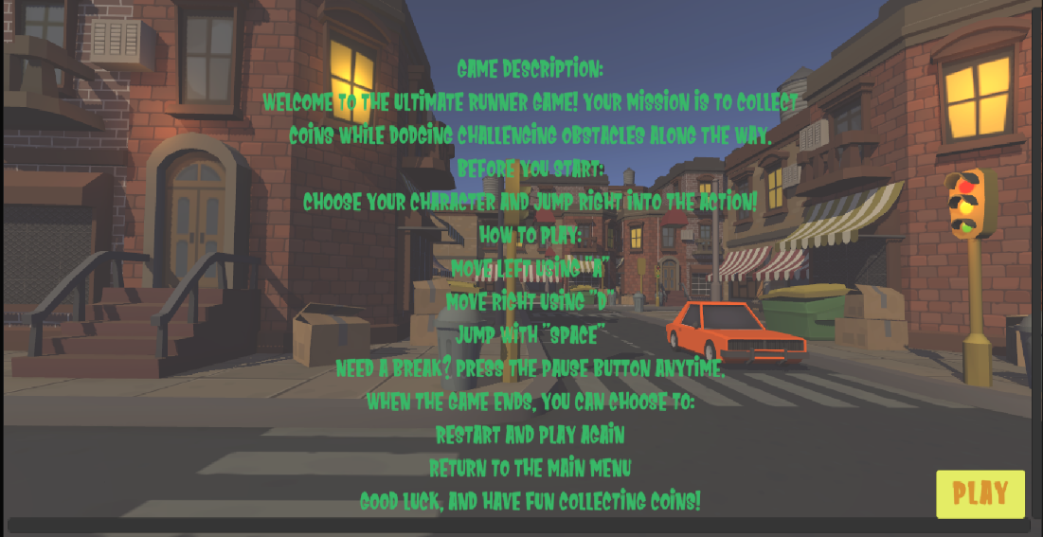

Slide Show:

The **slideshow section** tells the story of why each character enters the city or castle. As the story unfolds, players see a series of images or scenes that provide context and background for the characters' motivations. A **Skip button** is available for players who want to bypass the story and jump straight into the action.

Cut Scene:

The mood suddenly shifts as the character enters the city. The character pauses and looks about in surprise as they hear an odd voice reaching around them. They are shocked and frightened when the ghost appears out of nowhere as they turn. The character is confused, shouts, and starts to run to get away from the ghost. The game's opening sequence is made more tense and exciting by this cut scene, which also sets the mood for the chase.

Shop Scene:

The **shop interface** is designed for easy navigation, allowing players to view available items, their prices, and their current balance. The character is seen running in place, adding dynamic movement to the shop scene. On the right and bottom of the screen, there are **buttons** that offer various options: players can adjust settings, navigate to different areas like the **Castle** and **City**, or make purchases from the shop.

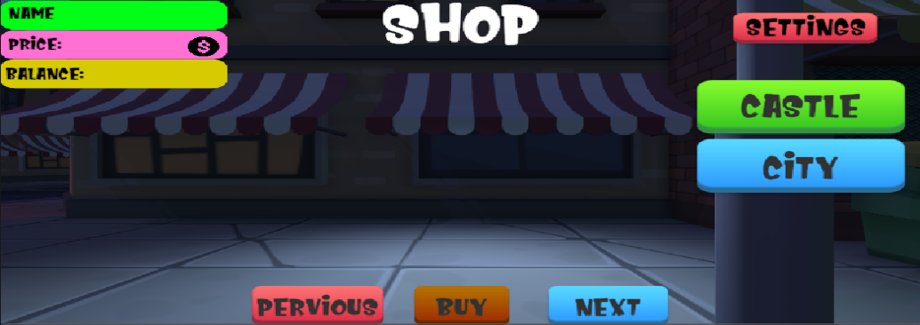

Game Play:

The gameplay interface provides essential information to enhance the player’s experience. A **coin counter** is displayed to track the number of coins collected during the run, encouraging players to gather more as they progress. A **timer** shows the time taken, adding an element of competition for players who aim to beat their best records. Additionally, a **pause button** allows players to take a break or adjust settings mid-game, ensuring flexibility and control during gameplay. These features work together to create a seamless and engaging experience for players.

Game Over state:

The **Game Over scene** features the ghost character as the central element, emphasizing the thrilling end of the run. The interface displays the player's **High Score** and **Total Balance**, giving a summary of their performance. Functional buttons such as **Next** allow players to proceed, offering options to restart the game or return to the main menu. The scene combines functionality with thematic design, ensuring players remain engaged even after their run ends.

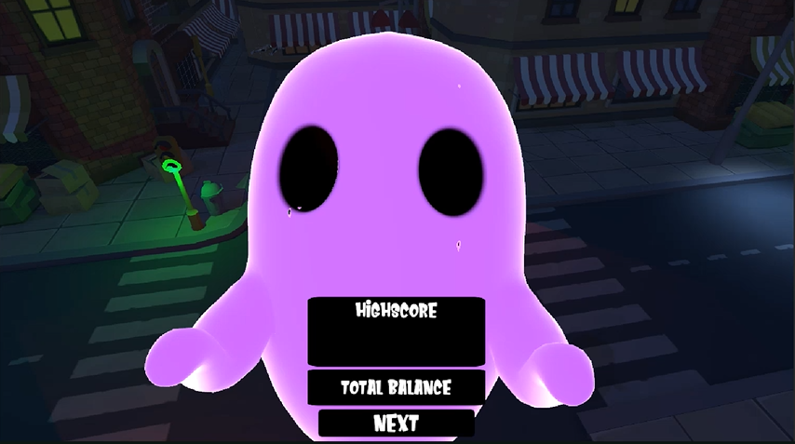

Lighting System:

The game features a dynamic **lighting system** designed to enhance each section's atmosphere. In the **main menu**, **directional light** and **baked point light** create a polished and static lighting setup for a clean and welcoming look. In the **cutscene**, **shop**, **gameplay**, and **game over scenes**, **real-time directional and point lights** are used to provide dynamic illumination that adapts to the environment and character movement. Additionally, a consistent **skybox** ties the visuals together, offering an immersive backdrop that complements the overall lighting system. This setup ensures a balance between visual appeal and performance.